Lesson 3
Algebraic Curves

SPECIFIC OBJECTIVES

At the end of the lesson, the student is expected to be able to:

- define and describe the properties of algebraic curves
- identify the intercepts of a curve
- test the equation of a curve for symmetry
- identify the vertical and horizontal asymptotes
- sketch algebraic curves

3.1 ALGEBRAIC CURVES

Definition 3.1 Algebraic Curves

An equation involving the variables x and y is satisfied by an infinite number of values of x and y, and each pair of values corresponds to a point. When plotted on the Cartesian plane, these points follow a pattern according to the given equation and form a definite geometric figure called the CURVE or LOCUS OF THE EQUATION.

The method of drawing curves by point-plotting is a tedious process and usually difficult. The general appearance of a curve may be developed by examining some of the properties of curves.

3.2 PROPERTIES OF CURVES

The following are some properties of an algebraic curve:
1. Extent
2. Symmetry
3. Intercepts
4. Asymptotes

Definition 3.2.1 Extent

The extent of the graph of an algebraic curve involves its domain and range. The domain is the set of permissible values for x and the range is the set of permissible values for y.

Definition 3.2.2 Symmetry

Two points with A and B are said to be symmetric with respect to a line L₁ if the line L₁ is the perpendicular bisector of the line segment AB. (Figure 3.2.2.1)

Two points A and B are symmetric with respect to a point O if O is the midpoint of the line segment AB. (Figure 3.2.2.2)

A
B
O
A
B
L₁
Figure 3.2.2.1
Figure 3.2.2.2

Test for Symmetry

From the definition of symmetry, the following tests are formulated:

1. Symmetry with respect to the x-axis
A curve is symmetric with respect to the x-axis if the equation does not change upon changing y to –y.

2. Symmetry with respect to the y-axis
A curve is symmetric with respect to the y-axis if the equation does not change upon changing x to –x.

3. Symmetry with respect to the origin
A curve is symmetric with respect to the origin if the equation does not change upon changing x to –x and y to –y simultaneously.

Example 3.2.2 Test the following curves for symmetry:

a. 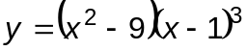 Ans: no symmetry
b. 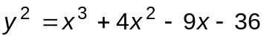 Ans: symmetric with respect to the x-axis
c. 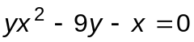 Ans: symmetric with respect to the origin
d. 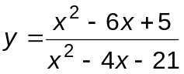 Ans: symmetric with respect to the origin
e. 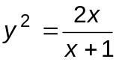 Ans: symmetric with respect to the origin and x-axis

Exercise 3.2.2 Test the following curves for symmetry:

1. 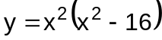
2. 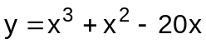
3. 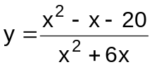
4. 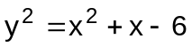
5. 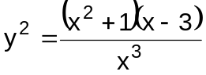

Definition 3.2.3 Intercepts

The intercepts are the points where the curve crosses the coordinate axes.

In tracing algebraic curves, consider two types of intercepts, namely:

1. x-intercepts
The abscissa of a point where a curve touches or crosses the x-axis is called an x-intercept. To find the x-intercepts, set y = 0 and solve the resulting equation for x.

2. y-intercepts
The ordinate of a point where the curve touches or crosses the y-axis is called a y-intercept. To find the y-intercepts, set x = 0 and solve for y in the resulting equation.

Example 3.2.3 Find the intercepts of the following equations:

a. Ans: x-int: 3, -3, 1 y-int: 9
b. Ans: x-int: -4, 3, -3 y-int: none
c. Ans: x-int: 0 y-int: 0
d. Ans: x-int: 5, 1 y-int: -5/21
e. Ans: x-int: 0 y-int: 0

Exercise 3.2.3 Find the intercepts of the following equations:

1.
2.
3.
4.
5.

Definition 3.2.4 Asymptotes

A straight line is said to be an asymptote of a curve if the curve approaches such a line more and more closely but never really touches it except as a limiting position at infinity. Not all curves have asymptotes.

There are two types of asymptotes, namely:

1. Vertical Asymptote
The vertical asymptote of a rational function 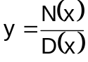 corresponds to the zeroes of the denominator D(x). Hence, if D(a) = 0, then x = a is a vertical asymptote. (Figure 3.2.4.1)

2. Horizontal Asymptotes

If y approaches the value b as x increases numerically without bounds, the line y = b is called the horizontal asymptote of the curve. To determine the horizontal asymptote, divide each term of both the numerator and denominator of the rational function by the greatest power of x then set x → ∞.
y = b
y
x
x = a
y
x
Figure 3.2.4.1
Figure 3.2.4.2

Example 3.2.4 Determine the asymptote/s of the following, if any:

a. Ans: none
b. Ans: none
c. Ans: v.a.: x = 3, x = -3 h.a.: y = 0
d. Ans: v.a.: x = 7, x = -3 h.a.: y = 1
e. Ans: v.a.: x = -1 h.a.: y = 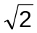 , y = -

Exercise 3.2.4 Determine the asymptote/s of the following, if any:

1.
2.
3.
4.
5.
3.3 TYPES OF ALGEBRAIC CURVES
There are four types of algebraic curves whose equations are as follows:
I. 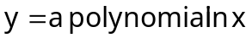
II. 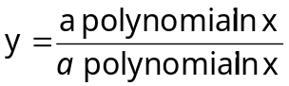
III. 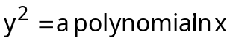
IV. 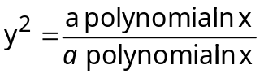

Example 3.3.1 Discuss and trace the curves of the following functions:
a.
- SYMMETRY
  - x-axis : not symmetric
  - y-axis : not symmetric
  - origin: not symmetric
- INTERCEPTS
  - x-intercepts: x = 3 x = -3 x = 1
  - y-intercepts: 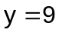
- ASYMPTOTES : none
- Graph

Region | Interval | x² – 9 | (x – 1)³ | y
I | x < -3 | + | - | -
II | -3 < x < 1 | - | - | +
III | 1 < x < 3 | - | + | -
IV | x > 3 | + | + | +

II
Figure 3.3.1.1
x
1
3
-3
I
IV
III
y

b.

- SYMMETRY
  - x-axis : symmetric
  - y-axis : not symmetric
  - origin: not symmetric
- INTERCEPTS
  - x-intercepts: x = -4 x = 3 x = -3
  - y-intercepts: none
- ASYMPTOTES : none
- Graph

Region | Interval | x + 4 | x – 3 | x + 3 | y² | y
I | x < -4 | - | - | - | - | i
II | -4 < x < -3 | + | - | - | + | +/-
III | -3 < x < 3 | + | - | + | - | i
IV | x > 3 | + | + | + | + | +/-

x
3
y
I
IV
II
III
Figure 3.3.1.2

-4
-3

c.
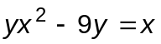
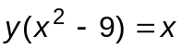
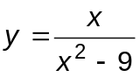

- SYMMETRY
  - x-axis : not symmetric
  - y-axis : not symmetric
  - origin: symmetric
- INTERCEPTS
  - x-intercepts: x = 0
  - y-intercepts: y = 0
- ASYMPTOTES
  - Vertical: x = 3 x = -3
  - Horizontal y = 0
The curve intersects the horizontal asymptote at x = 0.
IV. Graph

Region | Interval | x | x² – 9 | y
I | x < -3 | - | + | -
II | -3 < x < 0 | - | - | +
III | 0 < x < 3 | + | - | -
IV | x > 3 | + | + | +
II
y = 0
y
(0, 0)
x = -3
I
IV
III
x = 3
Figure 3.3.1.3
x

d. x²y² – 2xy² – x² – 3y² + 4x + 12 = 0
x²y² – 2xy² – x² – 3y² + 4x + 12 = 0
x²y² – 2xy² – 3y² = x² – 4x – 12
y²(x² – 2x – 3) = x² – 4x – 12
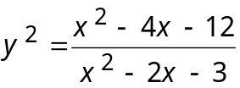
I. Symmetry
a) x –axis = symmetrical
b) y –axis = not symmetrical
c) origin = not symmetrical

II. Intercepts
a) x-intercepts: x = 6, -2
b) y-intercepts: y = ± 2

III. Asymptotes
a) Vertical Asymptotes: x = 3, -1
b) Horizontal Asymptote: y = ±1
c) Point of Intersection: 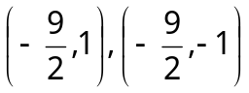
IV. Graph

Region | Interval | x - 6 | x + 2 | x - 3 | x + 1 | y² | y
I | x < -2 | - | - | - | - | + | +/-
II | -2 < x < -1 | - | + | - | - | - | i
III | -1 < x < 3 | - | + | - | + | + | +/-
IV | 3 < x < 6 | - | + | + | + | - | i
V | x > 6 | + | + | + | + | + | +/-
(6, 0)
(0, 2)
(-9/2, 1)
y
y = 1
(0, -2)
(-2, 0)
I
IV
II
III
x
V
y = -1
(-9/2,1)
Figure 3.3.1.4

Exercise 3.3. Discuss and trace the curves of the following:

1.
2.
3.
4.
5.
6. 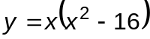
7. 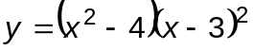
8. 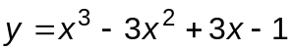
9 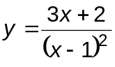
10. 